Assignment – 3

* **Use the Employee Details dataset and perform the following activities: -**
  + *Split the column CITY and separate the code associate with each city like – Allahabad [AL2] should be only Allahabad and [A2] will be separate.*
  + *Extract the first name from EMPLOYEE NAME column and transform the column.*

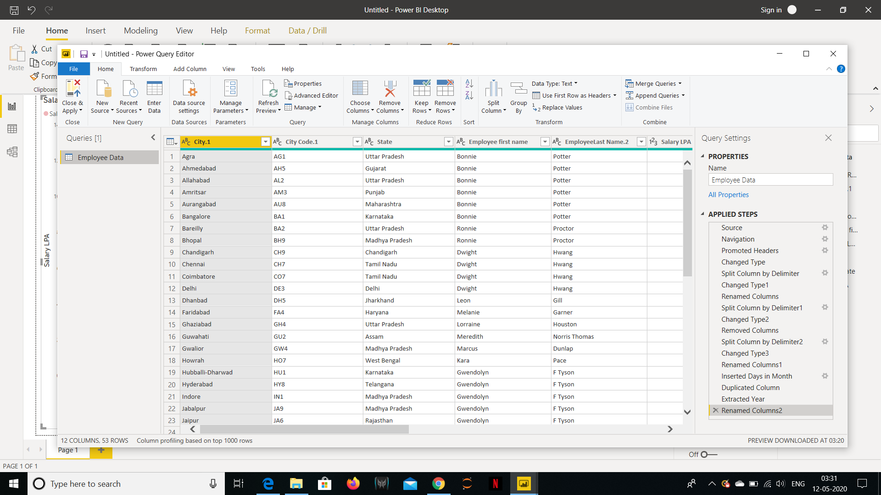

* + *Using the JOINING DATE column extract the Year and no. of days for that month .*

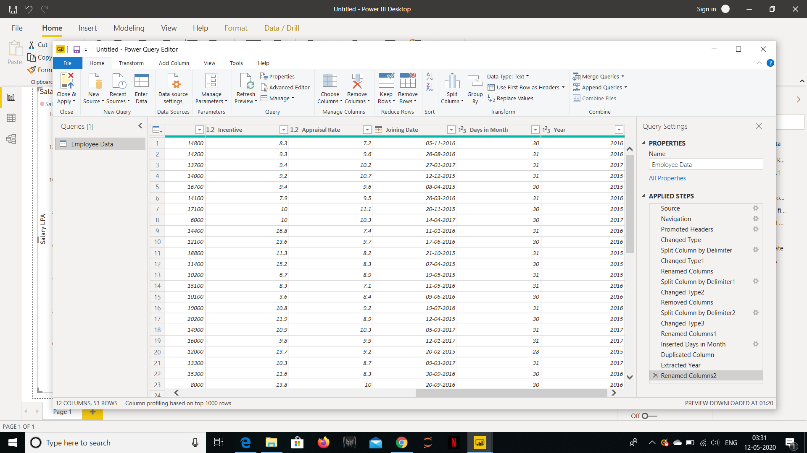

* + *Create a visual of your choice and show the how much salary has been paid to each state and which state has lowest payout.*

